**PRACTICAL NO: 05**

**AIM: Understanding, Reading and Analyzing routing tables of a network.**

**STEP 1**: Putting together all the devices and connecting them through cables.

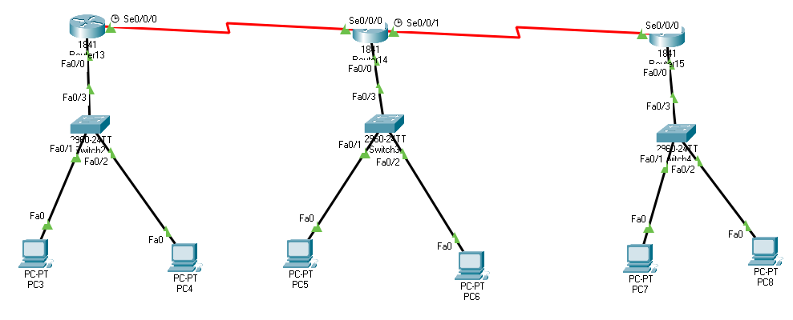

**STEP2:** Configuring IP addresses of End Devices.

**STEP 3:** Add a wireless serial connector module to a router

SAME FOR OTHER 2 ROUTERS

**STEP 4:** Configuring IP addresses on Routers / Gateways and Configuring IP addresses for Router-to-Router Serial Communication and switching them on for ROUTER 13.

**Step 5:** Configuring IP addresses on Routers / Gateways and Configuring IP addresses for Router-to-Router Serial Communication and switching them on for ROUTER 14.

**STEP 6:** Configuring IP addresses on Routers / Gateways and Configuring IP addresses for Router-to-Router Serial Communication and switching them on for ROUTER 15.

**STEP 7:** Configuring RIP Routing Protocol for Communication between all the devices across the Two Gateways.

SAME FOR OTHER 2 ROUTERS.

**STEP 8:** Checking if all the end devices across the network can communicate with each other.

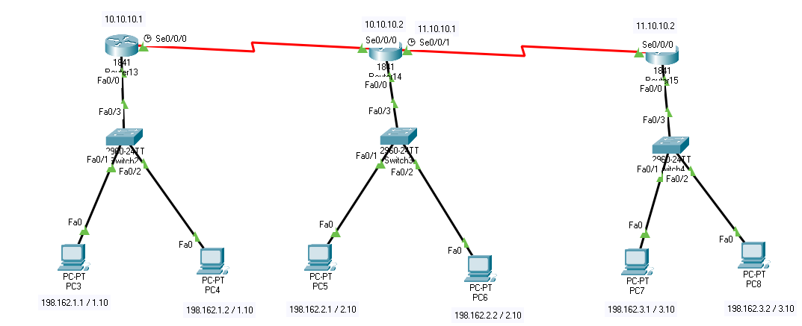

All the end devices can successfully communicate with each other.